Computer Networks

Week 9

UDP

John Juele

# Q1

UDP Headers

* Source Port
* Destination
* Length
* Checksum

# Q2



Length = 2 bytes

# Q3

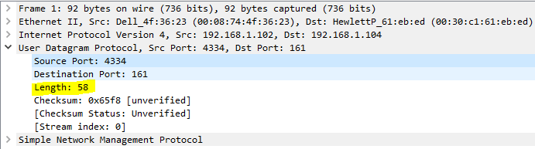

Length field = 58

# Q4

Max # of bytes = (2^16-1) – 8 = 65527

# Q5

Largest possible source port = 65535

# Q6

Protocol Number:

17/00X11

# Q7

The source port of the request is the destination port of the response message.